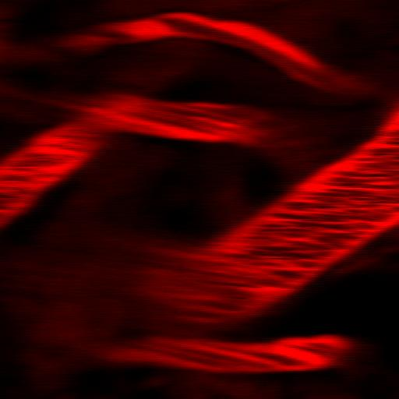a. **Image acquisition.** Fluorescent dyes or quantum dots are injected in the anesthetized animal to provide contrast with respect to non-fluorescent RBCs. Images are acquired by raster scanning a sample through confocal or two-photon excitation microscopy. The scan speed is chosen by live scanning the sample at increasing line-frequencies until flowing objects produce in the image diagonal lines, as shown in the figure superimposed to morphological details. The condition scan velocity > blood flow velocity must be satisfied.

10 m

**b. Image analysis.** A Region Of Interest (ROI) must be selected in the image, where diagonal lines appear. To extract the flow speed, the Cross-Correlation Function (CCF) of the fluorescence fluctuations detected in pairs of columns of the selected ROI has to be computed. In case of low contrast between fluorescent and dark stripes, a threshold can be applied to highlight the diagonal lines.

**c. Blood flow velocity computation.** CCFs computed for multiple column distances are then globally fitted to the analytical expression derived in [ref] to obtain the blood flow velocity estimate.

 The CCF is a peaked function that accounts for the parameters affecting the characteristics of the diagonal lines: properties of the flowing objects (size and diffusion coefficient), image acquisition parameters, column distances, flow speed and the orientation of the vessel with respect to the scan direction.

d. **Image sequence analysis.** Since the method can extract the flow velocity in vessels characterized by multiple relative orientations starting from a single image, kinetic studies can be performed in space and time through sequential imaging. It is also possible to monitor simultaneously morphological parameters of the microvasculature system (e.g. vessels diameter and density).

[ref] Sironi L, Bouzin M, Inverso D, D'Alfonso L, Pozzi P, Cotelli F, Guidotti LG, Iannacone M, Collini M, Chirico G., In vivo flow mapping in complex vessel networks by single image correlation., Sci Rep. 2014 Dec 5;4:7341. doi: 10.1038/srep07341.